Create a simple cloud software application for Hospital Management System using any Cloud Service Provider to demonstrate Software as a Service (SaaS).
Aim :
To Develop a hospital management system by using Zoho -CRM
Procedure:
- Create an organization in Zoho IAM.
- Deﬁne three user roles: Doctor, Patient, and Hospital.
- Create separate pages for doctors, patients, and hospital staff.
- Assign permissions to each role using Zoho IAM.
- Allow doctors to view and update patient details.
- Allow patients to view their medical details.
- Allow hospital staff to manage overall hospital information.
- Check that each role can access only its own page.

Output:
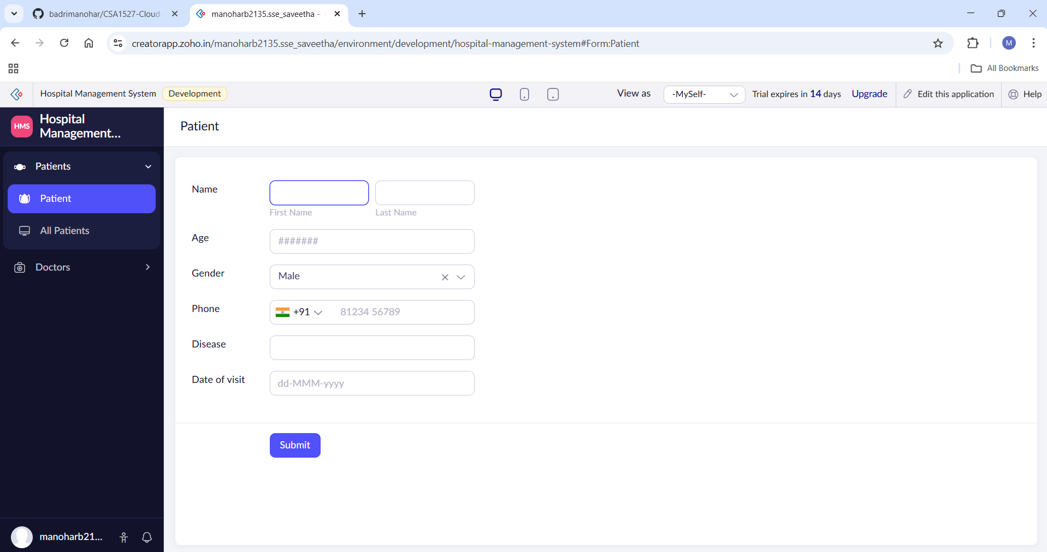
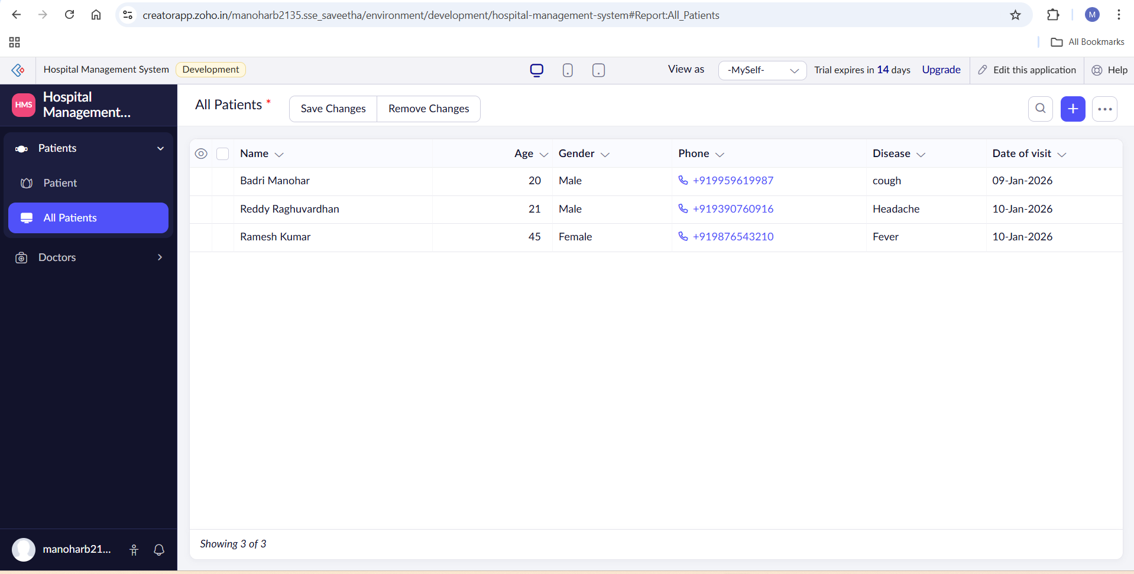
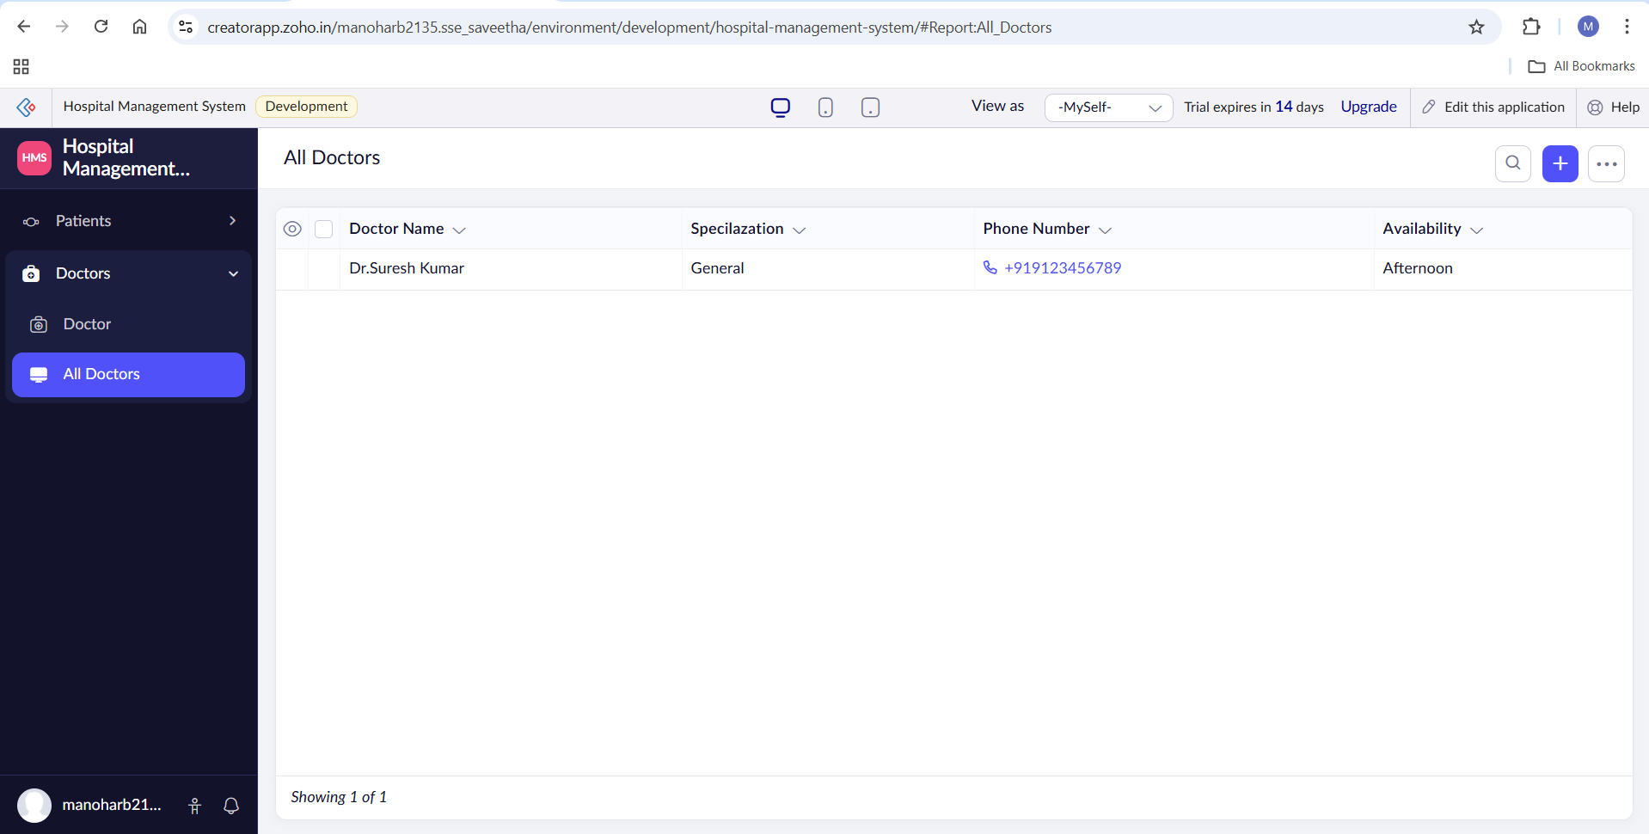

Result :
A simple cloud-based application was successfully developed and deployed using Zoho Creator. The application was accessible through the internet and demonstrated the concept of Software as a Service (SaaS).

